Micro PA50⁺

User manual

revise：2023-08-20

Introduction:
Micro PA50+ is an upgraded product based on Micro PA50. Compared with Micro PA50, it has the following upgrades
1. The upgraded display screen is a 1.3-inch OLED screen, which has a larger display area and is clearer and more intuitive.
2. Upgrade the thermal runaway management design, and improve the thermal stability again under the original high stability characteristics.
3. With the support of the new thermal runaway management, the IMD performance is improved to a new height, and the signal quality is better.
4. With the new LPF design, the power output of each frequency band is more balanced.
5. Upgrade the software algorithm, and the execution efficiency is higher.
6. Custom lengthened UHF-KYD RF connectors can now use non-standard plug-in connectors.
7. Optimize some hardware structure designs to improve the ability to resist falling.

Micro PA50+ inherits all the advantages of Micro PA50 at the same time, it is a 50W intelligent portable shortwave power amplifier. With high-speed automatic transmission and reception switching, it can automatically switch between receiving and transmitting without using an external PTT control line; similarly, it also has the function of high-speed automatic switching of LPF filters, and there is no need to connect the band control line, any QRP shortwave radio station can be used perfectly; And it has perfect power and standing wave display and protection functions; voltage display and protection functions; temperature display and intelligent heat dissipation and temperature protection functions; and the CW semi-plug-in mode function has also been added; of course, it also supports the use of external PTT control Receive and transmit switch and band control line switch LPF filter, and support ICOM band switching protocol and XIEGU brand band switching protocol at the same time.

parameter:
Frequency range: 3.5MHz-28.5MHz (incremental support to 29.8MHz)
Input power: 2-5W
Input standing wave: ≦2.0@50Ω
Maximum output power: 40-50W
Output impedance: 50Ω
Output standing wave protection: 1:3.0(≦10W); 1:2.0(≧10W)
Supply voltage: 8.5V-17.5V (up to 14.2V for machines before 2023); 13.8V (typical value)
Current consumption: ≦12A
Maximum working temperature: ≦60℃
Dimensions: 88*38*143 (excluding protrusions); 88*38*160 (including protrusions)
Weight: about 600g

Front panel description:
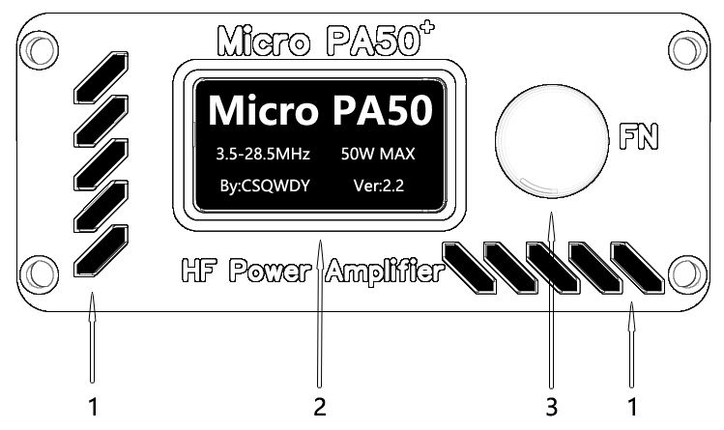

1: Cooling air intake
2: 1.3 inch OLED display
3: Multi-function button

Rear panel description:
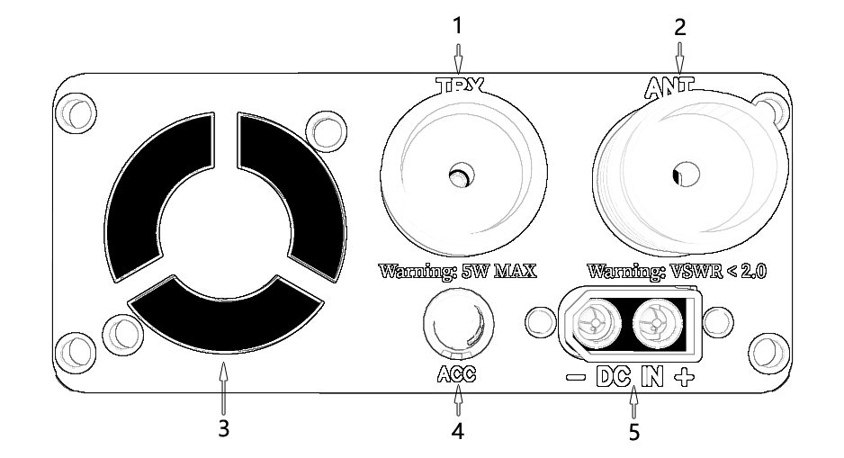
1: radio interface
2: Antenna interface
3: cooling fan
4: ACC interface (use 3.5 three-pin plug)
5: Power interface (type XT-60)

Display description:
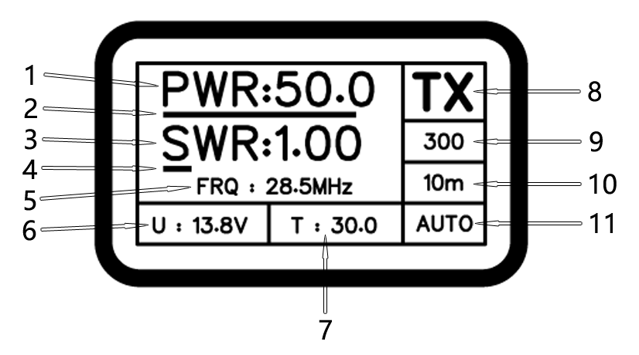
1: Power display in digital mode
2: Power display in the analog bar display mode (the maximum value is 55W in power amplifier mode, and the maximum value in standing wave meter mode is 150W)
3: digital standing wave ratio display (the maximum value is 99.9)
4: VSWR display in the analog bar display mode (the maximum value is 9.99)
5: Frequency display
6: Power supply voltage display
7: Temperature display (Celsius)
8: Power amplifier status display; turn off the power amplifier display as "OFF", and transmit status display as "TX"
9: CW semi-insert mode delay parameter display; no delay display "BKIN"
10: band display
11: Working mode display. The automatic mode is displayed as "AUTO", the ICOM band switching protocol is displayed as "ICOM", and the XIEGU band switching protocol is displayed as "X-GU"

ACC interface description:
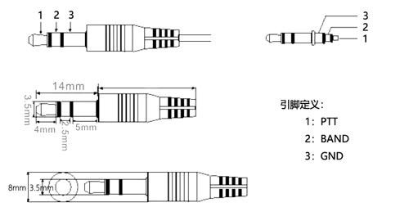

Simple operation guide:
1. Connect the antenna to the ANT interface.
2. Connect the radio to the TRX interface, and adjust the output power of the radio to about 2W.
3. If necessary, connect the ACC interface to the ACC interface of the radio.
4. Connect the power cord to the dedicated power supply or battery of the radio station, and then insert it into the power socket of the power amplifier.
5. Press the transmitter button of the radio station and observe the output power of the power amplifier. If the power does not reach 50W, please increase the output power of the radio station. Otherwise, please reduce the output power of the radio station. But in any case, don't put the output power of the radio more than 5W.
6. In SSB mode, it is recommended to set the delay parameter of CW semi-insert mode to more than 150ms, and the recommended setting is 200-300ms.
7. When using the antenna tuning equipment to tune the antenna, the output power of the power amplifier should be controlled within 10W or the power amplifier should be set to OFF.

Quickly familiarize yourself with the key functions:
Note: The serial number represents the number of quick presses.
1: Release the current protection and alarm.
2: Switch the delay parameter of semi-insert mode, display BKIN as 0, 100-3000ms.
3: Manually switch bands.
4: No function.
5: Band protocol mode switching.
6: Power and standing wave display mode switching, SSB mode is recommended to use P.H mode to observe the power situation more intuitively.
7: No function.
8: Enter unlimited mode (Warning! Entering this function will void the warranty!)
Press and hold for 3 seconds: turn off or turn on the power amplification mode, the off mode can be used as a power standing wave meter, and the maximum measurement is 150W.

Function Description:

1. RF trigger switching of high-speed detection mode
No need to connect external PTT control line in this mode.
The RF trigger of the high-speed detection method is realized by the interrupt method, so the response speed is very fast. According to the test, the response time is less than 2ms. With this automatic trigger, you don't need to connect the PTT control line, and the power amplifier will be automatically switched into transmit mode by the signal you input.

2. Automatic switching of LPF filter
In this mode, the corresponding LPF filter switching can be automatically completed without connecting the band control line.
Design a frequency detection module on the circuit, so that it can automatically switch to the corresponding LPF filter according to the frequency of the RF signal input from your radio station to the power amplifier, that is to say, you don’t need ICOM or XIEGU’s band switching protocol. Automatically complete the corresponding LPF filter switching. And the entire detection switching speed is less than 100ms (Note: With the continuous update of the software, this data will change slightly).

3. CW semi-insert mode function
Even if the station does not have a CW half-insert mode, it is not afraid, this amplifier has an adjustable half-insert mode function.
The half-insert delay time can be switched by double-clicking the multi-function key, and the range is 100ms-3s. Special reminder: Due to the influence of program running speed, according to the test, there will be an error of ±30ms in this time.

4. Real-time display of power and standing wave
When the power is less than 10W and the VSWR exceeds 3.0 or the power is greater than 10W and the VSWR exceeds 2.0 or the power exceeds 56W, the power amplifier will be automatically turned off, the corresponding flashing display will show the value that triggered the protection, and the buzzer will alarm.
Note: The maximum value of the power dynamic bar is 55W, and the maximum value of the standing wave dynamic bar is 9.99. When the power amplifier is turned off (power meter mode), the maximum value of the power dynamic bar is 150W.

5. Temperature detection and temperature protection
When the temperature is higher than 35 degrees, the cooling fan is turned on, and when the temperature is lower than 34 degrees, the cooling fan is turned off. If the temperature is higher than 60 degrees, the power amplifier will be turned off, and the reminder will flash and the buzzer will alarm. When the temperature is below 60 degrees, the power amplifier will be automatically activated.
At the same time, when the power amplifier is in the transmitting state, the fan will start immediately. When the transmission stops and the temperature is lower than 34 degrees, the fan will be turned off after a delay of 10 seconds. If the temperature is higher than 34 degrees, the fan will continue to work. The fan will be turned off until the two conditions of the temperature below 34 degrees and not in the launch state are met.

6. Voltage real-time display and high and low voltage protection function
When the voltage is lower than 8.5V or higher than 17.5V, the power amplifier will be turned off. The hardware is designed with a transient suppression diode for when the voltage is higher than 18.8V (Note: the machine produced before 2023 is 15.8V) or the power supply is positive and negative. Protect the power amplifier from damage when the poles are reversed. Of course, this protection requires a fuse, which is designed on the external power line.
The function of turning off the power amplifier when the voltage is lower than 8.5V will be very friendly when you go outdoors and use a lithium battery for power supply, and will not cause battery damage due to over-discharge of your lithium battery.

7. Frequency display function.
Real-time display of the current transmitting frequency with an accuracy of 100KHz.

Function operation instructions:

1.turn on or off the power amplifier
Long press the multi-function button to turn on or off the power amplifier. After the power amplifier is turned off, "OFF" will be displayed in the "power amplifier status display" area of the display.

2. Turn off power protection or standing wave protection
During power protection or standing wave protection, short press the multi-function button once to turn off the current protection.

3. CW semi-insert mode parameter adjustment
Double-click the multi-function button to cycle through the delay parameters of the CW semi-insert mode, and the delay parameter adjustment range is 100ms-3000ms. When it is displayed as "BKIN", it means that the CW semi-insert mode function is turned off.

4. Manually switch bands
In AUTO mode, switching from high band to low band, since it takes 100ms to detect the switching band, there will be relatively
Large harmonics, it is recommended to use manual switching when switching from high band to low band. Press the multi-function key 3 times in quick succession to cycle through the bands. Manual band switching has lower priority than AUTO and ICOM or XIEGU band switching protocol modes.

5. Band switching protocol selection
Support ICOM and XIEGU band switching protocols, select by pressing the multi-function key 5 times in rapid succession. (Note: V1.4 and above software version)

6. Power standing wave display mode switching
Quickly press the multi-function key 6 times to switch the power standing wave display mode. They are normal mode (R.T) and peak hold (P.H) mode respectively. SSB recommends using the peak hold mode, which makes it easier to check the power and standing wave status. (Note: V1.8 and above software version)

7. Used as a separate power standing wave meter
After turning off the power amplifier, the power amplifier can be used as a power standing wave meter, the maximum power measurement is 150W, and the maximum standing wave measurement is 99.9. For how to turn off the power amplifier, please refer to function 1.

8. Turn on unlimited mode
Press the multi-function button 8 times in rapid succession to enter the unlimited mode. Before the prompt content is displayed on the screen and the countdown is not over,
Press the multi-function key 8 times in rapid succession to cancel the unlimited mode. Once in unlimited mode, you need to power cycle to exit this mode.
In this mode, the output power will not be limited, please use it with caution. And it is still recommended not to input more than 5W.
⚠WARNING: Once unlimited mode is turned on, the warranty will be void. Any problems caused by this will be borne by the user.

Precautions:
1. Please abide by relevant radio laws and regulations to use this power amplifier legally.
2. Do not use unmatched antennas, feeders or RF connectors.
3. Do not reverse the positive and negative poles of the power supply.
4. Do not connect the power supply to a power supply with a voltage exceeding 18.8V (products before 2023 should not exceed 15.8V).
5. Do not use this power amplifier in thunderstorms, and disconnect the antenna connector in thunderstorms.
6. Do not use this power amplifier in rain, water or in a humid environment with a humidity greater than 75%.
7. Do not disassemble the power amplifier without authorization. Touching the components on the circuit board of the power amplifier in the transmitting state may burn your skin due to high-frequency signals.

special reminder:
1. The automatic band switching function switches from the high band to the low band, and there will be a situation in which large harmonics are output instantaneously. If this produces
If there are concerns, it is recommended to use manual band switching or ICOM and XIEGU band switching protocols to control the band switching of the power amplifier.
2. When using end-fed antenna or GP antenna, please ground the antenna feed correctly, and use a choke coil to suppress the interference caused by unbalance.
Otherwise, it may cause abnormal power and standing wave detection of the power amplifier, and even cause the software to crash.
3. In SSB mode, when using RF trigger mode for RF switching instead of external PTT control, it is recommended to use the half-insert mode to prevent frequent sending and receiving switching in voice gaps, and the parameters of the half-insertion mode can be adjusted to more than 150ms.
4. With the continuous upgrade and improvement of software and hardware, software functions and performance will be slightly different without prior notice!
appendix

Micro PA50⁺ Firmware Upgrade

Required tools: TTL 5V level serial port module small board, you can use CH340, CH341, CP2102 and other serial port modules, it is recommended not to use PL2303 module.

Download and unzip the firmware upgrade tool AVRDUDESS and firmware.

Execute the firmware upgrade tool "avrdudess.exe", and select the port of the small board of the serial port module as the port (check it in the computer device management). Select the firmware file in Flash, and then set other parameters according to the figure below.
Warning: Do not check the "Erase flash and EEPROM" option.
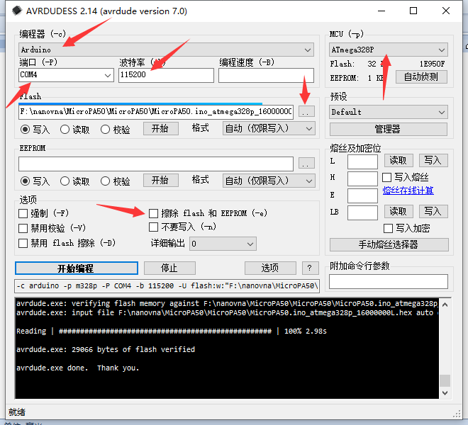

Remove the screws on the upper case, and find the firmware upgrade port near the fan, which corresponds to the firmware upgrade port connecting the small board of the serial port module to the power amplifier.

Firmware upgrade port definition:
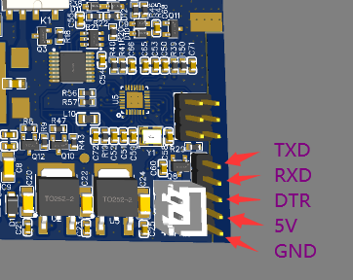

Corresponding connection to serial port module small board
Power Amplifier Serial Port Module
TXD ---- RXD
RXD----TXD
DTR ---- DTR
5V ---- 5V
GND ---- GND
Note: If the small board of the serial port module does not have DTR, it can also be connected to the RTS of the serial port module

Click the "Start Programming" button in the software. Wait for the execution to complete.
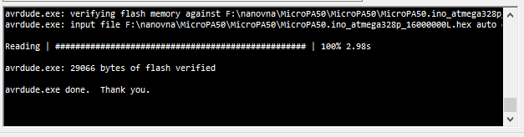

Remove the cable and install the case.

Other possible problems:
1. If the small board of the serial port module or the USB of the computer cannot provide a sufficiently stable 5V voltage, it may cause the upgrade failure. Please do not worry, just connect the power amplifier to the power supply, and disconnect the 5V on the power amplifier firmware upgrade port to the serial port module. 5V connection line is enough.

2. The remedy for cleaning up the EEPROM by mistake
function reminder
N: SN code
I: reference voltage
S: save data.
F: The power calibration instruction F1000 is 100.0% (reminder: this calibration is forward power, please do not modify it without an instrument)
R: Standing wave calibration instruction R1000 is 100.0% (reminder: this calibration is reverse power, please do not modify it without an instrument)

1. Follow the upgrade tutorial to connect the TTL serial cable.
2. Use any serial port debugging tool software, correctly select the COM port, and connect.
3. Send the content of the PA50 display to the email csqwdy@qq.com, please send the content displayed on the screen in text, and take photos of the entire panel and the main board. Wait patiently, you will receive an email containing the SN code.
4. Fill in the content "N sn content Enter" in the sending content area of the serial port debugging tool software, such as "N 1234-5678-9012-3456", and add a carriage return. Note that you must enter a carriage return without double quotation marks.
5. Send the above information, pay attention to observe whether the receiving window of the serial port debugging tool software returns this content correctly.
6. Send another one with the content of "S" and press Enter. Pay attention to see if the receiving window prompts that the storage is successful.
7. If necessary, recalibrate the reference voltage, the content is "I voltage", for example, "I 5012" means the voltage is 5.012V, this voltage needs to measure the voltage output by CJ7805, and pay attention to sending "S" for storage.
8. The power and standing wave parameters generally do not need to be calibrated. If you have a higher specification instrument, you can calibrate it according to the above instructions, and pay attention to sending "S" for storage.

